March 2025
Greetings from the USA Embassy of the Confrérie du Sabre d’Or!
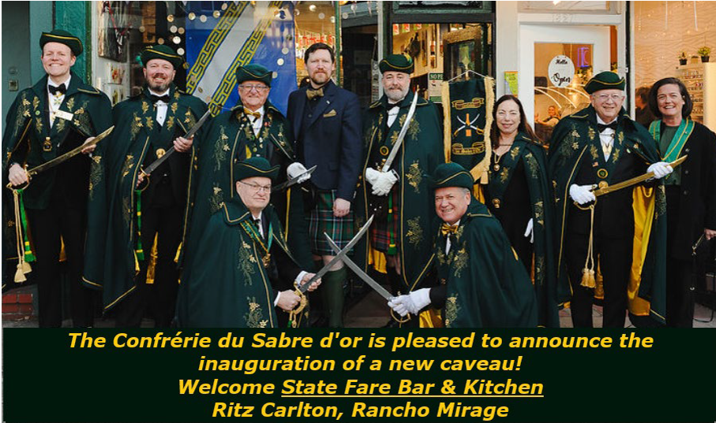

Coming up on March 21 in Rancho Mirage, CA, we are excited to announce State Fare Bar & Kitchen will be inaugurated as a new caveau by the US Grand Council of the Brotherhood of the Golden Saber.
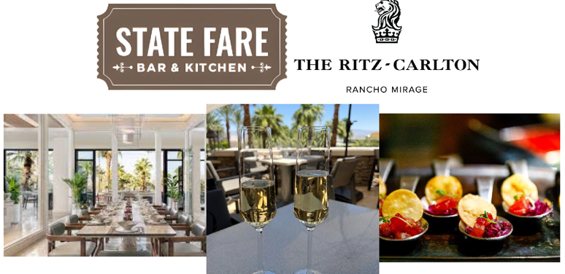

March came in like a lion and the extraordinary events that have taken place already this month are no exception. We welcomed record numbers of new members and promoted members with 44 new sabreurs, 27 new chevaliers, 5 new Maître sabreurs, 2 members d’honneur and one new officer.
The eclectic sites for the new caveaux were brimming with bubbles and good eats as we welcomed Le Grand Conseil (Grand Council) of our international champagne order who traveled from France and Asia to join us in establishing the new caveaux and all our newest members.
Officials in Attendance
Jean-Claude Jalloux founding member and titular head (Grand Maître) of Le Grand Conseil
Henry Widler Gouverneur Asie Pacifique (Governor Asia Pacific),
Pascal Rozee Maître du Protocole International (Head of International Protocol)
Chris Noon Head of Communications, United Kingdom
Philippe Milgrom Gouverneur USA (Governor USA)
Sebastien Taveau Consul for Northern California
Jordan Yelinek Trésorier General (Treasurer) / Connétable de San Francisco (Constable)
Jeanne Ruderman Maître du Protocole (Head of Protocol) USA

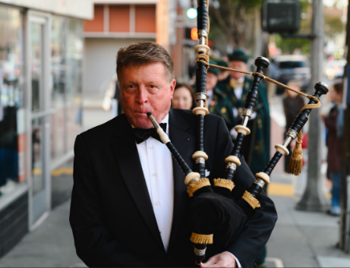
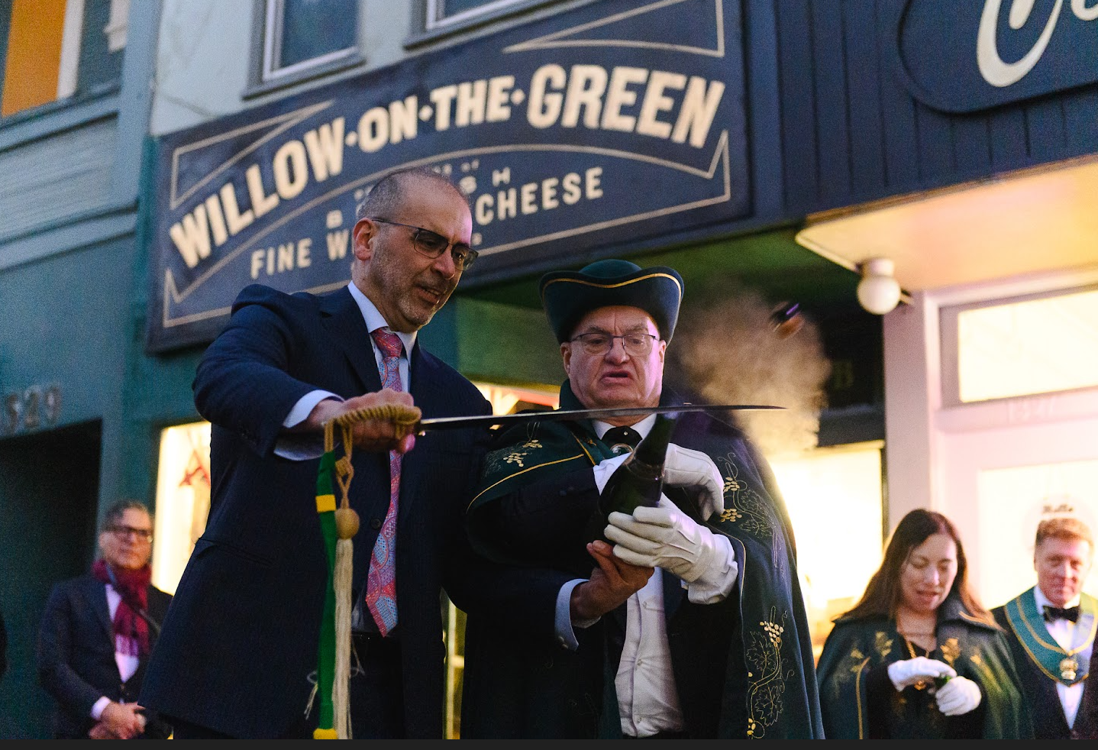

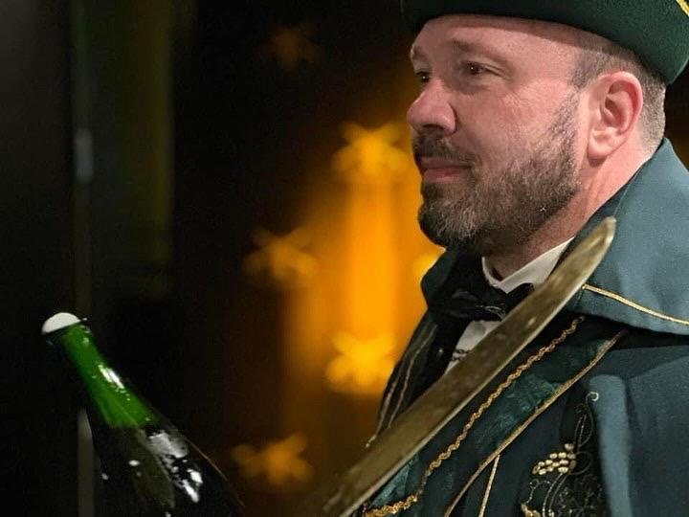
Our first new caveau was Willow on the Green (pictured above), San Francisco’s only British cheese shop. While they sell a good selection of British and French cheeses as well as many champagnes, we all know there is no cheese without French Champagne and our own Alexandra Sainz was there to provide plenty of bottles for sabering. The next time you find yourself in need of cheese and champagne, be sure to stop into Willow on the Green. You can pick up a bottle of Alendra Sainz while you’re there!
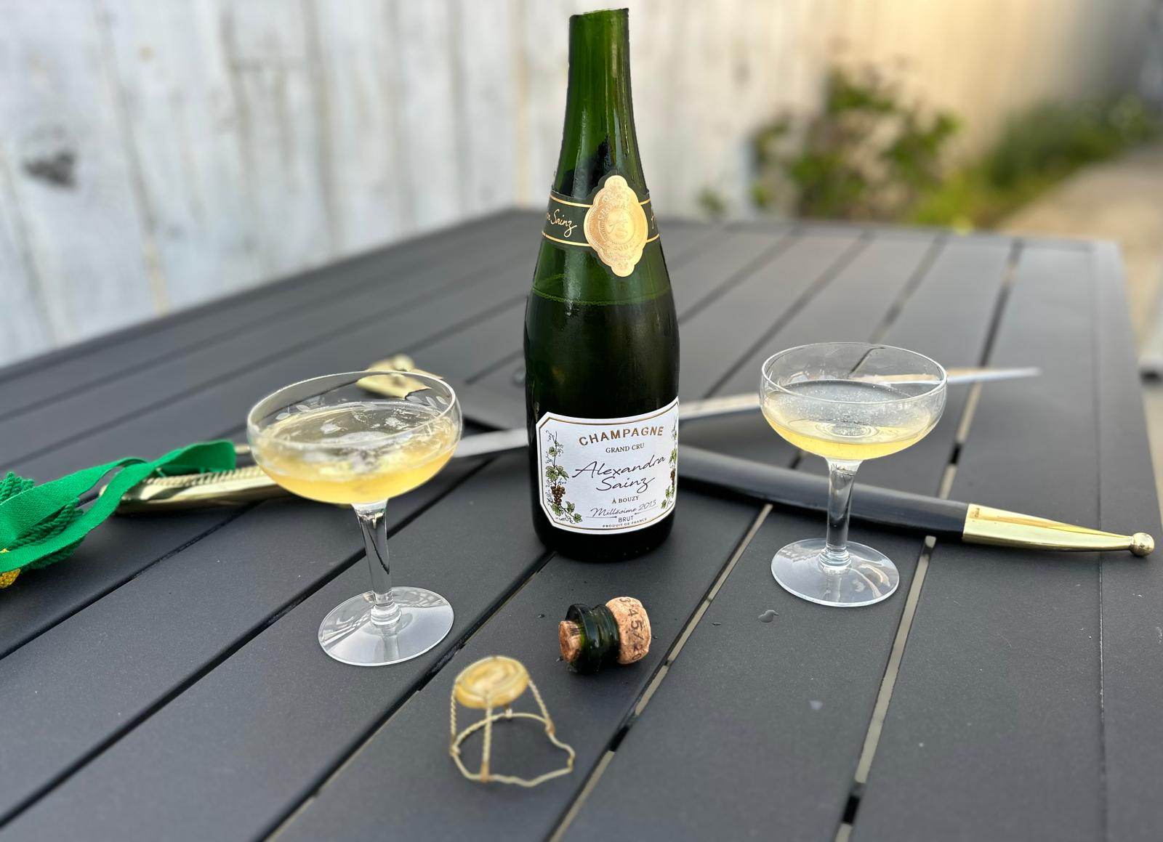

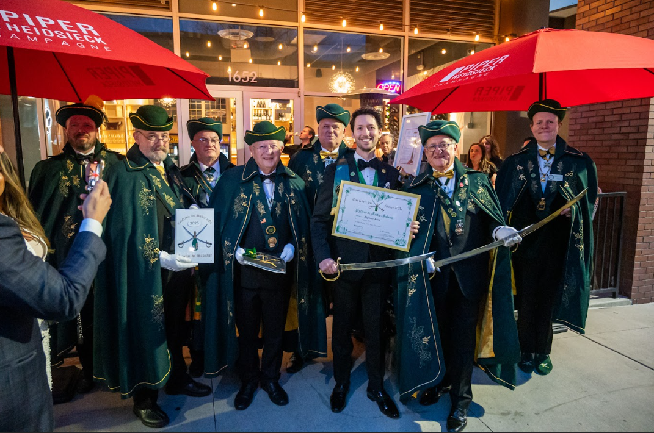
Next (caveau) stop, The Battery. This exclusive, members only, social club in San Francisco had 27 members sabering to add 19 sabreurs, 6 chevaliers, one maître sabreur and one new officer. If you’re not a member but you are looking to experience The Battery’s exclusive service, you can book a hotel room at the 2 Michelin star hotel. This place exudes luxury in spades!
Our brotherhood then headed to the East Bay to Fizz in Walnut Creek. Fizz is all about champagne and food that goes well with champagne. They’re tagline is “Celebrating the Everyday…Every Day!” They offer an immersive champagne experience where you can taste at least 10 different champagnes by the glass. You can even join their champagne club. We welcomed 5 new chevaliers, one new maître sabreur and 3 new sabreur members at Fizz, pictured below.

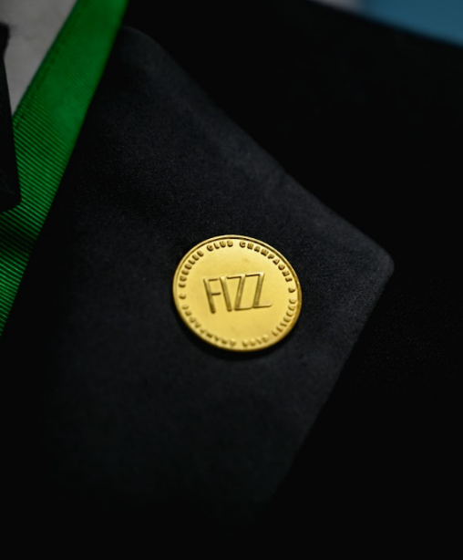
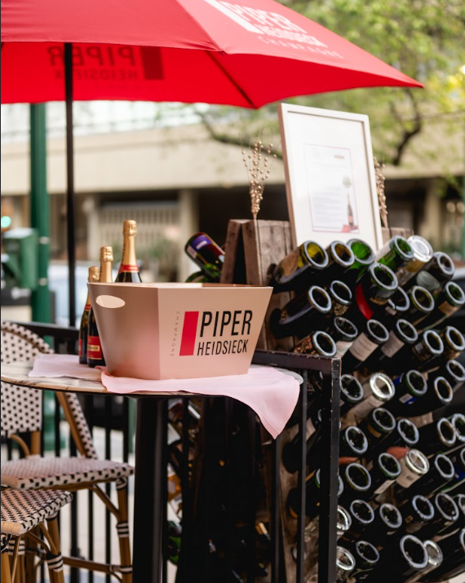

Our main event took place at Tasting House in Los Gatos. The Grand Council oversaw 18 new sabreurs, 7 chevaliers and 2 maître sabreurs. Tasting House offers no fewer than 6 champagnes by the glass and over 100 different champagnes by the bottle while taking pride in delicious food that goes well with wine and champagne.

But that wasn’t all. We were also excited for our membre d’honneur (member of honor) Tommy Roe, the Bubblegum King of rock and roll whose career spanned over 60 years.

Tommy wrote, co-wrote and recorded six top ten hits between 1962 and 1969 on the Billboard Hott 100, including “Dizzy” and “Sheila” which both reached #1. Dizzy stayed at #1 for four weeks and sold over 10,000,000 records making it one of the biggest hits of 1969.
Tommy is pictured below with the honorable Jean-Claude Jalloux founding member and titular head (Grand Maitre) of Le Grand Conseil who traveled from France to be with us.
Tasting House
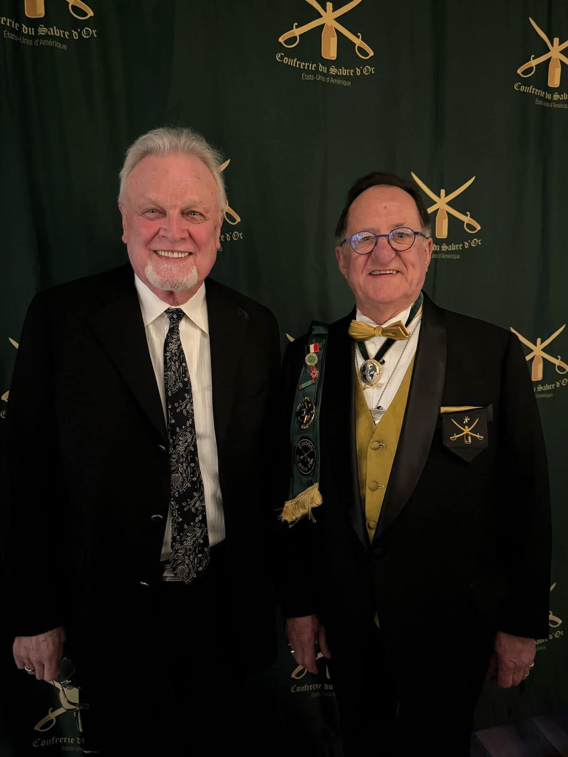

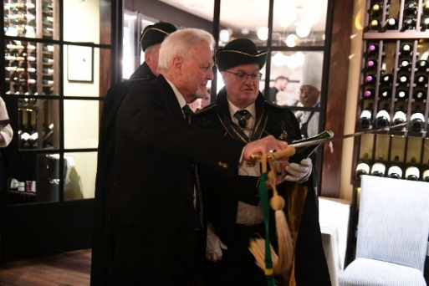
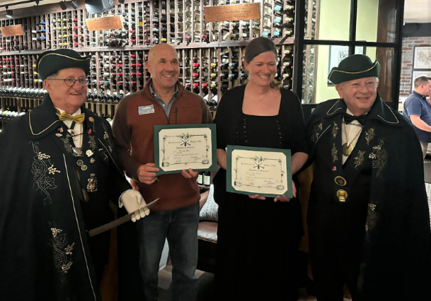
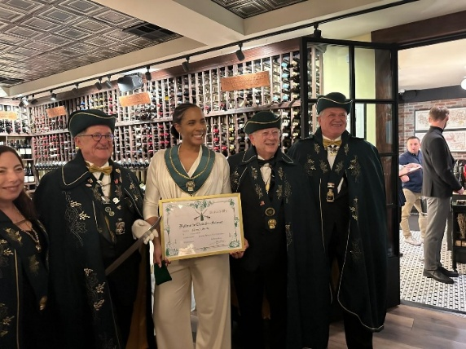
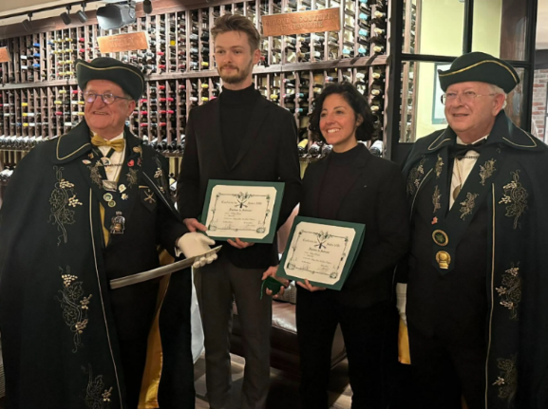

Congratulations to all our new and promoted members and remember…
“Santé, Bonheur, Champagne!”
If you are interested in holding a Sabrage event near you, please let us know – Contact Information follows. Also, please let us know if you would like to purchase your own official, Confrérie Saber! Our Sabers are made in the traditional method, in France and are engraved with your name as well as the Confrérie logo.
Please note, if you have not yet paid your membership dues for 2025, please do so by April 15. Dues that have not been paid by 4/15 will result in your membership being placed on hold.

Danielle Spandau, Head of Communications
Northern California Chapter, USA
dspandau@gmail.com

CONFRÉRIE DU SABRE D’OR - USA EMBASSY

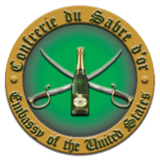

Directory of Consuls for the USA Embassy:


Ratu Muda Princess Karen Cantrell, Consul for Southern California ratumudaprincess@gmail.com

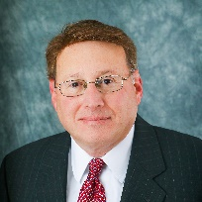
Brian Mandel, Consul for New Jersey bkmandel@optonline.net

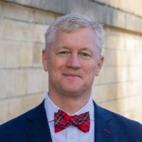
Robert Scruggs, Consul for Northern Georgia travelingbacchus@yahoo.com

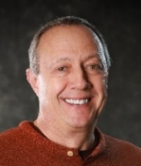
Marc Verstaen, Consul for Washington
marc@verstaen.com

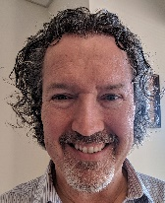

Darryl Gugig,
Secretary General
dgugig@gmail.com

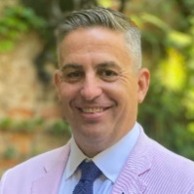
Christian Pendleton, Consul for Louisiana cpendleton@neworleans-food.com

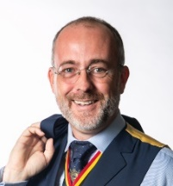
Sebastien Taveau, Consul for Northern California
staveau@gmail.com


Aaron Habibipour, Consul for Massachusetts
aaronhabibipour@gmail.com

Jordan Yelinek, Constable for San Francisco / Treasurer General
jordanyelinek@gmail.com

Confrerie du Sabre d'Or - France

Confrérie Links:
 https://www.facebook.com/SabredorUS

Confrerie du Sabre d'Or - Grand Council (France)

Confrerie du Sabre d'Or - Switzerland

https://twitter.com/ratumudapk

Confrerie du Sabre d'Or - Singapore

Confrerie du Sabre d'Or - UK & Ireland

